Normal Distribution Exercise Set
I. 1) The random variable Z has µ = ______ and σ = _____.
2) P(0 < z < 1.53) =
3) P( z > -2.18) =
4) Find the value of z_{o}, such that P( -z_{o} < z < z_{o}) = .92.
5) Find the value of z_{o}, such that P(z < z_{o}) = .3015.
II. The random variable X is normally distributed with mean 80 and standard deviation 12.
1) What is the probability that a value of X chosen at random will be between 65 and 95?
2) What is the probability that a value of X chosen at random will be less than 74?
III. The random variable X is normally distributed with mean 65 and standard deviation 15. Find x_{o}, such that P(x > x_{o}) = .6738.
IV. The scores on a placement test have a mound-shaped distribution with mean 400 and standard deviation 45.
1) What percentage of people taking this exam will have scores of 310 or greater?
2) What percentage of the people taking this test will have scores between 445 and 490?
V. A test has been devised to measure a student's level of motivation during high school. The motivation scores on this test are approximately normally distributed with a mean of 25 and a standard deviation of 6. The higher the score the greater the motivation to do well in school.
1) What percentage of students taking this test will have scores below 10?
2) John is told that 35% of the students taking the test have higher motivation scores than he does? What was John's score?

Answers
I. 1) μ_{Z} = 0 σ_{Z} = 1
2)
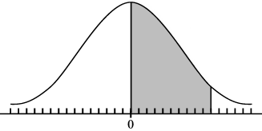
1.53 P(0 < z < 1.53) = .4370.
3)
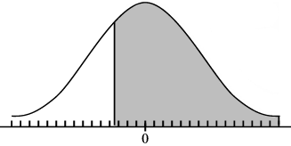
-2.18 P( z > -2.18) = .9854.
4)Find the value of z_{o}, such that P( -z_{o} < z < z_{o}) = .92
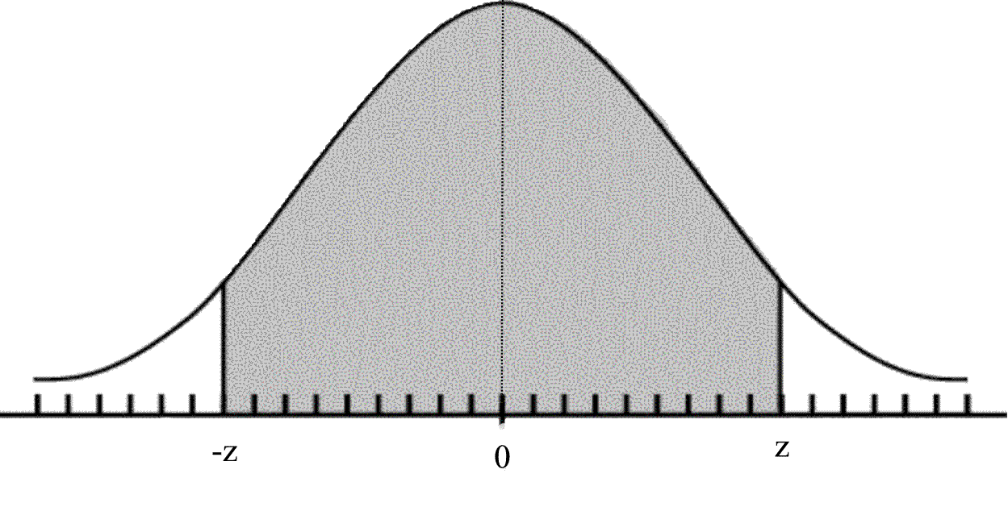
-z_{o} z_{o} Since P(-z_{o}<z<z_{o})=.92, we know that P(0<z<z_{o})= .4600.
z_{o} = 1.75
5) Find the value of z_{o}, such that P(z < z_{o}) = .3015.
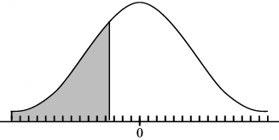
z_{o} Since P(z < z_{o}) = .3015 which is less than .5, we know that P(z_{o} < z < 0) =.5 -.3015 =.1985. Hence, by symmetry z_{o} = -.52
II. 1) P(65 < x < 95) =.7888 2) P(x < 74) =.3085.
III. x_{o} = 58.25
IV. 1) P(x > 310) = .9772 97.72 % of the people taking this test will have scores of 310 or greater.
2) P(445 < x < 490) = .1359 13.59 % of the people taking this test will have scores between 445 and 490.
V. 1) 0.62% of the students taking this test will have scores below 10.
2) John's score was 27.34

